City of Saskatoon’s Accessible Pedestrian Signals

In Saskatoon, we’re making crossing the streets safer for people with low vision. We now have Accessible Pedestrian Signals (APS) at 193 out of 323 signalized intersections across the city. Touchless APS are installed at 25 of these intersections. These signals use sounds to help know
when it is safe to cross.

The APS button makes a beeping sound to let people know it is there. Most buttons have raised arrows to show which way to cross. To use it, press the button or wave your hand in front of the button for a few seconds. You’ll hear a click and a message to wait. That means the APS is on.
When it’s time to walk, the APS makes sounds and the arrow vibrates. Different sounds help you know which way to go. A cuckoo sound means it is safe to go north or south, and a chirp sound means east or west.

When the sounds stop, it’s time to wait again. Don’t start crossing if the sounds stop or the arrow stops vibrating. Finish the crossing if you are already in the middle.

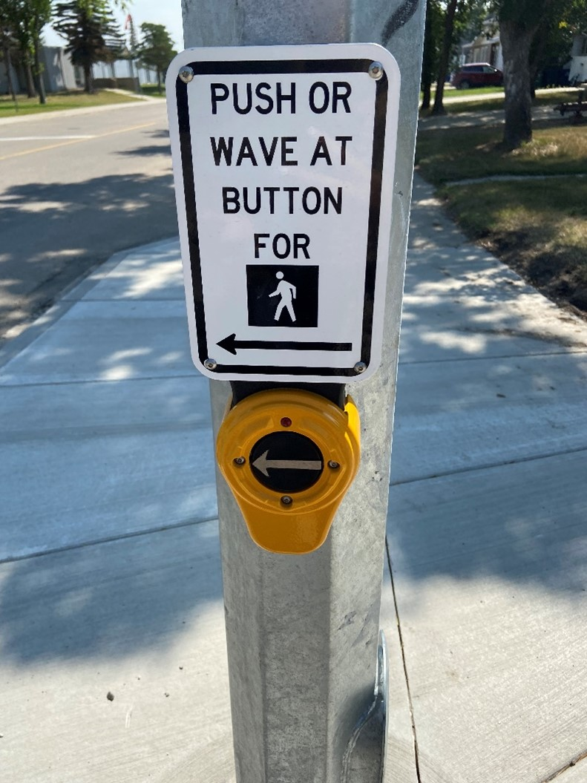
Touchless APS
APS can be activated by waving your hand in front of
the push-button or by pressing the push-button.

