YMCA Property and Surrounding City-owned Properties
treet
Wall
12
14
204
211
225
208
220
261

2022
23rd
Drive
Pacific
Ontario
16
9
15
24
38
50
221
213
154
247

2022
Idylwyld
Street
Blue Line BRT
Green Line BRT
Red Line BRT
39
211
146
142
225

2022
Street
102
137
140
168
182
149
BRT

Stop
Avenue
125
130
131
145

2021
111
123
115
116
140
124
141
North Lot
2021

2022
Wall
Pacific
Avenue
1st
115
128
102
140
101
101
140

BRT
Green Line BRT
22nd
104
102
Stop
25

Red Line BRT
Street
35
110
130

1960s to 1970s
Drive
YMCA
Avenue
101
101
110
101

2013
115
120

2013
1st
126

TCU
2013
111

1964
Fire Hall No. 1
2n
125
122
123

1910s
Idylwyld
105

2021
Avenue
140

Midtown Plaza
155
157

167
123
215
201

21st

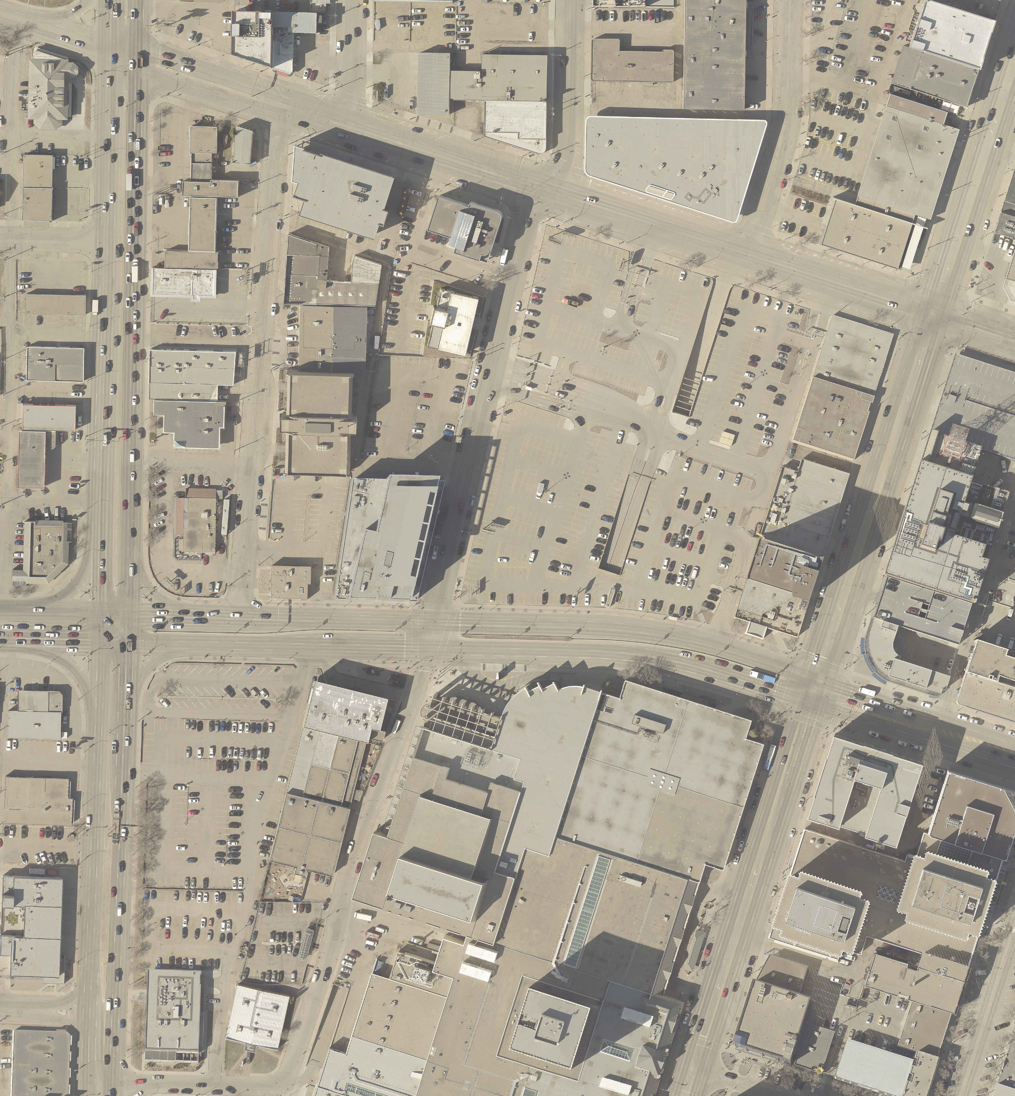
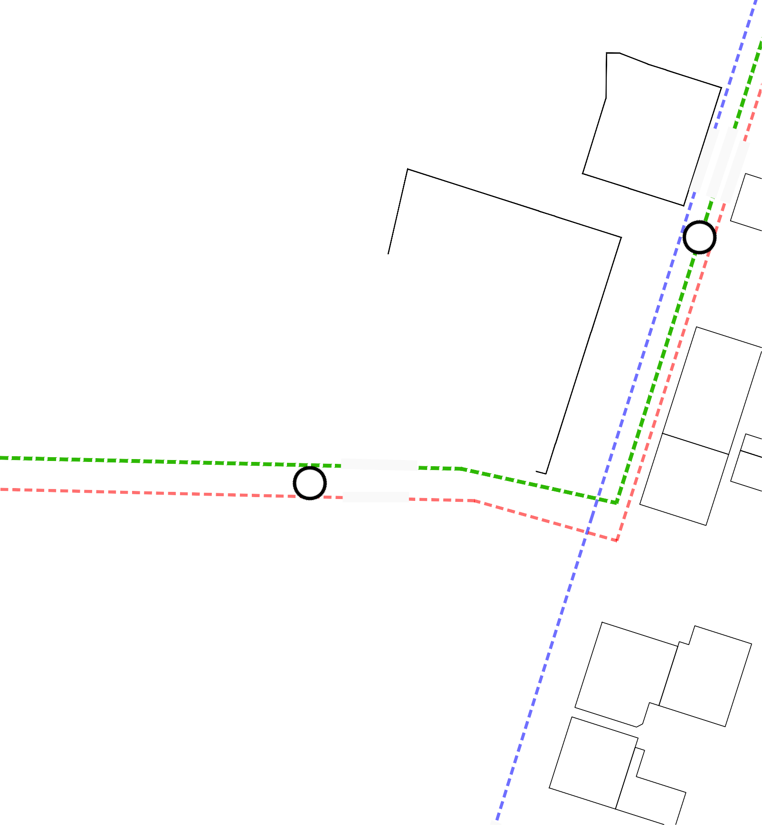
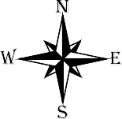
YMCA Property Under Agreement
Auditorium
130
154
183
25 - 22nd Street East

Year shown on property indicates the year it was acquired by the City

City Owned
35 - 22nd Street East
105 & 123 Auditorium Ave
110, 120, 125, 126, 140 Idylwyld Drive North
140, 141, 149 Pacific Ave
39 & 50 23rd Street East 145 - 1st Ave North

Real Estate Services - February 2024
Note: The City does not guarantee the accuracy of this drawing. To ensure
accuracy, please refer to the Registered Plan of Survey. This drawing is not to scale. Distances are in metres unless shown otherwise. Do not scale.

