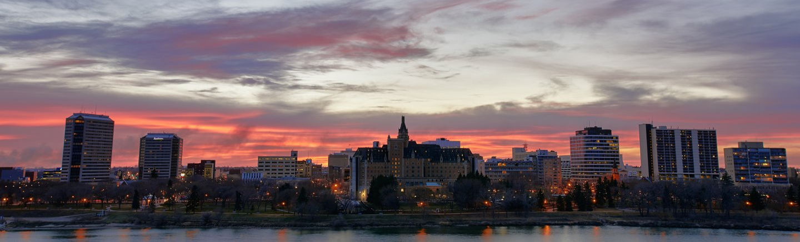

Building on Success in the City Centre

Source: Discover Saskatoon, Mark Tiu Photography

In the years since 2013’s City Centre Plan, progress has been made towards transforming Saskatoon’s urban heart. The changes are apparent in the streets, public spaces, and skyline of the City Centre. Taking stock of the work that’s been done, and highlighting the successes, is important as we set out to address the work and significant challenges that remain.
Over the last decade, milestone decisions to locate future landmark facilities, changes to public policy, investments in public spaces and amenities, and new private developments are bringing growth and change to the City Centre.
The following is an overview of highlights from this period. Some relate directly to actions identified by the City Centre Plan, while others emerged out of other plans and initiatives. Some were City-led, with others led by or involving community partners, other orders of government, and the private sector. All of them relate to realizing a transformative vision for Saskatoon’s City Centre as a vibrant destination and premiere location to live, do business, and enjoy community.
Setting the Template for Growth
Foundational decisions to route new transportation connections and locate future anchor facilities set the template for a generational transformation of the City Centre:
- The Bus Rapid Transit system’s route configuration and its connections to and through the City Centre.
- Downtown Active Transportation Network routes along 3rd Avenue, 19th Street, and 23rd Street.
- A Permanent Outdoor Festival Site at Friendship Park.
- The New Central Library on the 300 block of 2nd Avenue North.
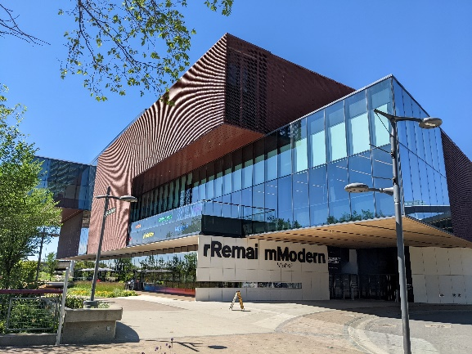
- The Event Centre/Arena on the Midtown Shopping Centre North Parking Lot on 22nd Street East to anchor the future Downtown Event and Entertainment District.
Enriching the Public Realm
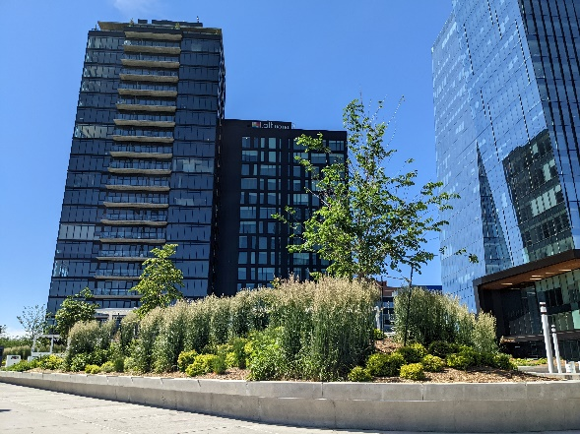
The opening of new and renewal of existing anchor facilities have enriched the City Centre’s cultural and leisure offerings:
Remai Modern
- Opening of Remai Modern as the cultural centrepiece of River Landing.
- Nutrien Playland at Kinsmen Park, part of a family-oriented hub at Downtown’s northern edge complemented by Nutrien Wonderhub, a children’s museum in the former Mendel Art Gallery.
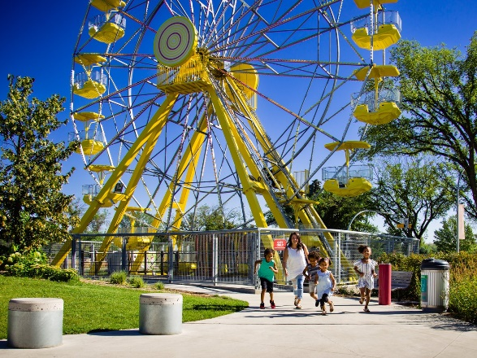
- A permanent home for Shakespeare on the Saskatchewan on the riverbank, including a main stage, tiered seating, pavilion buildings, and new Meewasin Trail connections.
K.W Nasser Plaza at River Landing
- A reimagining of the Farmers’ Market Building at River Landing, reopening in 2024 as Gather Local Market, a public market operating 6 days a week with options to eat, drink, and shop, along with a seasonal outdoor market.

Nutrien Playland | Source: Discover Saskatoon, Sik Pics
Enhancement of our streets, parks, trails and public spaces are positioning the City Centre as a people place:
- Renewal of 21st Street East, Downtown’s signature street and one of the first streetscape projects from over 30 years ago.
- K.W. Nasser Plaza, a privately-owned public space at River Landing.
- Ongoing upgrades to well-used segments of the Meewasin Trail in and near the Downtown.
- Pawâtêtân Court, a landmark outdoor basketball court and new riverside amenity located between Victoria Park and River Landing.
- New seasonal decorative lighting on street light poles throughout the City Centre.
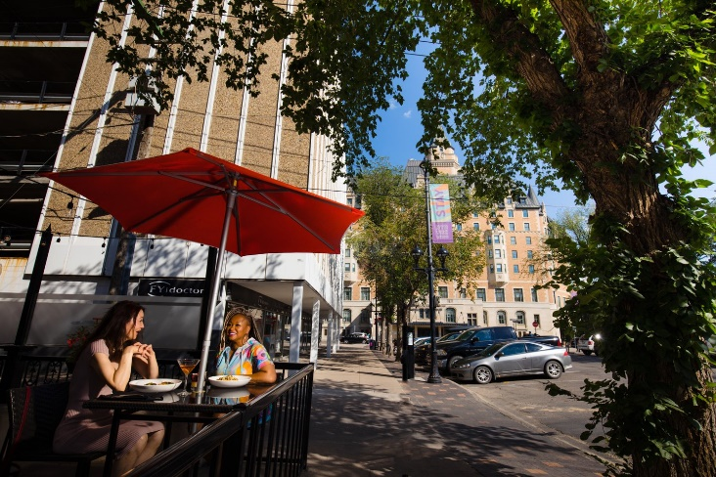
- Decorative lighting to help animate a prominent Downtown back alley.
- Installation of new streetscapes on 25th Street East, between 1st Avenue and Idylwyld Drive, and 20th Street West from Avenue E to Avenue H.
- New streetscape improvements in 2024 to 20th Street East between 1st Avenue and Idylwyld Drive.
- Completion of a master plan to improve the function, safety, connectivity, and quality of the roadway and public realm along Idylwyld Drive, between 20th Street and 25th Street.

Evolving the Rules
Public policy needs to change with the times. Improvements to rules and regulations around doing business and developing property sets a foundation for growth:
- Allowing for the development of parking patios in public parking spaces, providing new opportunities for outdoor seating for eating and drinking establishments.
- Increasing opportunities for restaurants and outdoor seating to establish along Spadina Crescent.
Source: Discover Saskatoon, Sik Pics
- Adoption of density bonusing provisions to allow buildings in Downtown’s B6 zone to exceed the 76 metre height maximum in exchange for public amenities.
- New regulations in Downtown zones to help ensure quality of new development, including street interface, building form and massing, and wind mitigation for pedestrian comfort.
- Broadening and enriching the tax and grant-based incentives available for development in the City Centre.
- Waiving offsite levies for new development in the City Centre.
- Simplifying and streamlining development requirements in the Downtown.
- Creation of a dedicated staff resource to assist development projects in the City Centre navigate zoning, permitting, and other regulatory requirements.
- Ongoing work to review and implement amendments to Downtown zoning districts to better reflect current building practices, emphasize flexibility, and encourage development while ensuring a high-quality built environment.
Investment and Growth
Private investment has responded with projects that have brought new homes, businesses, offices, and hotel rooms to the City Centre. Significant developments since 2013 include:
- A major-mixed use development on Parcel YY, the signature development site of River Landing. The project includes approximately 360,000 square feet of office space, a residential condominium, hotel, public parking, new spaces for shops and restaurants around a central plaza, and Saskatchewan’s tallest building.
- The Banks, a mixed-use development with residences and commercial space on the Riversdale side of River Landing.
- A comprehensive renovation to the Midtown shopping centre.
- Adaptive reuse of the former Saskatoon Police Service headquarters for commercial space.
Tees & Persse Building
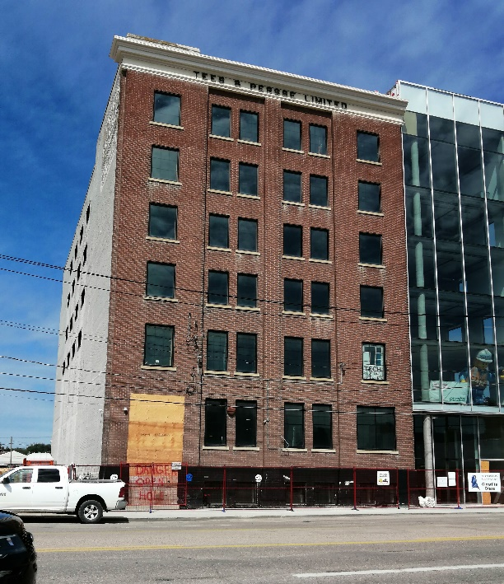
- Renovation of historic brick warehouses on 1st Avenue North for commercial space, including the Tees & Persse Building, one of Saskatoon’s newest municipal heritage properties.
- Baydo Towers, a residential project on 25th Street that, once complete, will house close to 500 residential units, making it the largest residential development in Saskatoon.
At the time of writing of this report, hundreds more residential units at various stages in the permitting and development planning processes are proposed within projects throughout and near to the City Centre.

